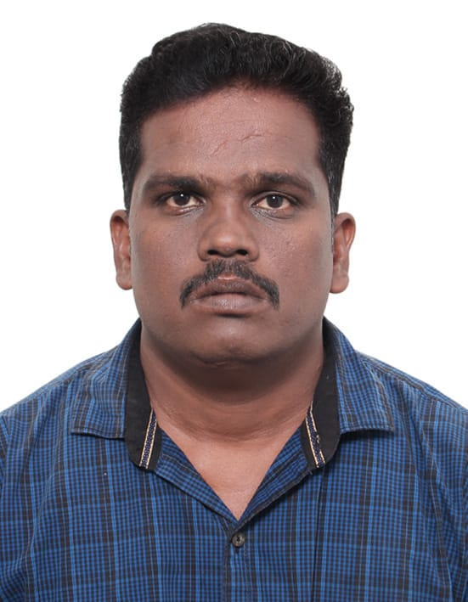

R.S.SURESH
MOBILE NO: 00973-35539040

E-Mail: rss9566540765@gmail.com

Seeking assignments in Admin & Stores Department with a growth oriented organisation of repute

Professional Synopsis

- Over 14 years of experience in Construction Industry, office admin,Procurement, Co-ordination and Store Management.

- Resourceful in managing office admin and worker issues

- Resourceful in managing civil and mobilization of material encompassing finalization of prices.

- Extensive experience in inventory updates and stock checks through HISYS & ERP Package.

- Possess excellent communication, analytical, interpersonal, team management and organisational skills.

Core Competencies

Procurement & Store Operations.

- Managing the Purchase and Store Operations& superviseing.

- Efficient administration of purchase at the project.

- Adequate knowledge of local market about the material and Negotiation with the supplier for reduction in prices.

Liaison/ Coordination

- Co-ordination with Project Manager / Administrative Manager / Procurement Manager / QA & QC Manager and other Management authorities for uninterrupted flow of work.

- Weekly review with all top Managerial authorities for uninterrupted flow of work.

- Maintaining good relationship with all superiors and staff at all level.

Documentation

- Preparing Local Purchase Order , Material Tracking System, Price Comparison and Supplier
Assessment.

- Maintaining all official documents at user level as per the guidelines of ISO 9002:1994.

Career Graph with Noteworthy Accomplishments

Current Employer
Working as Office Admin & Site SUPER VISIOR in
ADWAN MECHANICALCONTRACTING BAHARAIN From October 2019 to Till now

Previous Employer:
Working as Office Admin & Manaintance supervisor in Vastek solutions pvt ltd in Trichy From December 2015 to September 2019.

Previous Employer:
Worked as Office Admin & Site SUPER VISIOR in Top a India contractor pvt ltd in Chennai From December 2012 to November 2015.

Previous Employer:
Worked as Office Admin & Site SUPERVISIOR in Kenizo Construction Company, in Singapore From August 2010 to December 2012.

Previous Employer:
worked as procurement officer & stores in charge, Robust Contracting Co. LLC in DUBAI from March 2007 to September 2009.

Previous Employer:
Worked as Purchase Officer & stores in charge M/s. VAAS INDUSTRIAL Pvt. Ltd., Chennai, from June 2005 to March 2007

Educational Qualification

- BSC (IT). From Bharthidhasan University, Trichy, INDIA. 2002 – 2005

- MBA (finance management). From periyar University, Salam, INDIA. 2008 -2010

- PGDCA(Human resource management) From Annamalai University Chidambaram2011- 2012

IT Skills

MS office, ERP, HISYS (Inventory Package)

Personal Details

Date of Birth : 25th April 1984

Passport No. : M7479380

Languages : English, Hindi, Malayalam, Tamil & Little Arabic

Marital Status : Married

Nationality : Indian

Present Add : North Street Pennakkonam (Po) kunnam (Tk) perambalur (Dt) .

CONTACT No : 35539040

Reference : Available Upon Request

Official Oath:

I hereby certify that all statement made by me on this application are true and correct to the best of my knowledge and belief

-------------------
R.S.SURESH

